Binah Ndeh

Homework 2

1. Define the following terms;

**a. html**

Hypertext Markup Language. Used to convert private resources to public (internet)

**b. http**

Hypertext Transmission. Used to transmit webpage or web content from one system to another.

**c. How is Internet different from www**

www: stands for world wide web, It is a combination of internet resources. Internet is a collection of local networks in the globe

**d. How is http different from https**

https is encrypted information while http is a clear text

**e. URL**

Uniform Resource Locator . It gives a path to resources in the web

**f. How is a Systems Admin different from a Network Admin and a Systems Engineer**

Network Admin : Manages one server e.g Windows / LINUX

Sys Admin : Manages two or more systems

Sys Engineer : Can build networks from scratch

**g. Blade Server**

It is a type of server that is rack mountable

**h. LCD**

Liquid Crystal Display. A type of monitor which is lightweight and portable

**i. LED**

Light Emitting Diode. Upgrade of LCD with clearer pictures

**j. CRT**

Cathod Ray Tube. Old time large box monitor where electrons hit the screen and glow

**k. Switch**

Device that connects network systems together

**l. Router**

Connects LANs together.

**m. Networked System**

It is a system of LAN sharing information

**n. Application**

A program designed to perform a specific task and must be installed on an OS

**o. IT**

Information Technology. Use of technology to create and manage data

**p. Hosted Hypervisor**

The application version of a hypervisor the must be installed on an operating system

**q. Vmware Host**

It is a system that has a hypervisor installed on it.

**r. Bare Metal Hypervisor**

It is the operation system version of a hypervisor that can be installed on a physical system or bare metal platform.

**2. Watch the following "Windows Desktop Support Video" and increase the performance of your windows system.**

**Downloading windows updates**

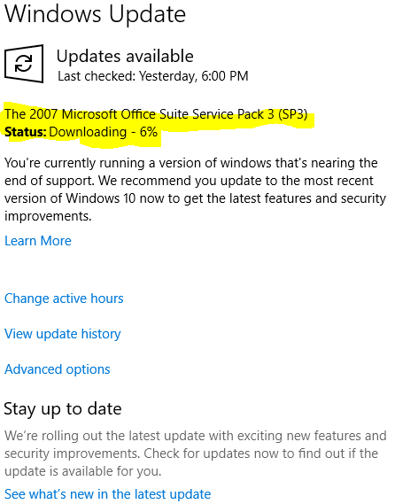

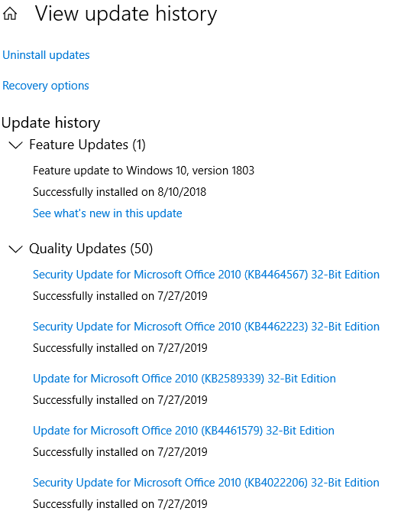

**Cleaning Disk**

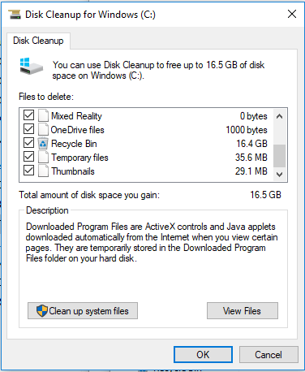

**Scanning for malware**

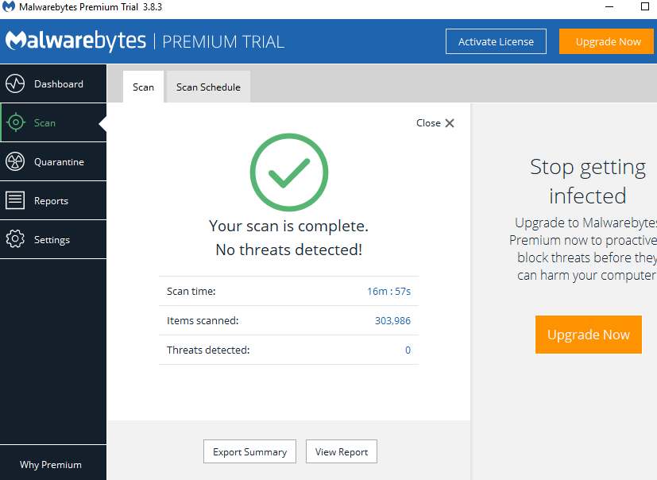

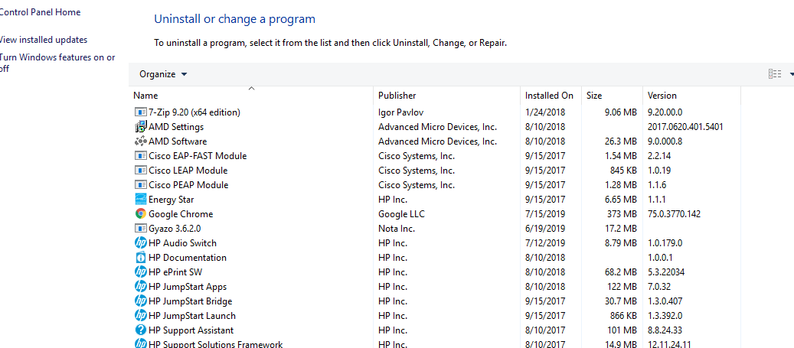

**.**

**Using Windows PowerShell to find corrupted files. Kept this running overnight**

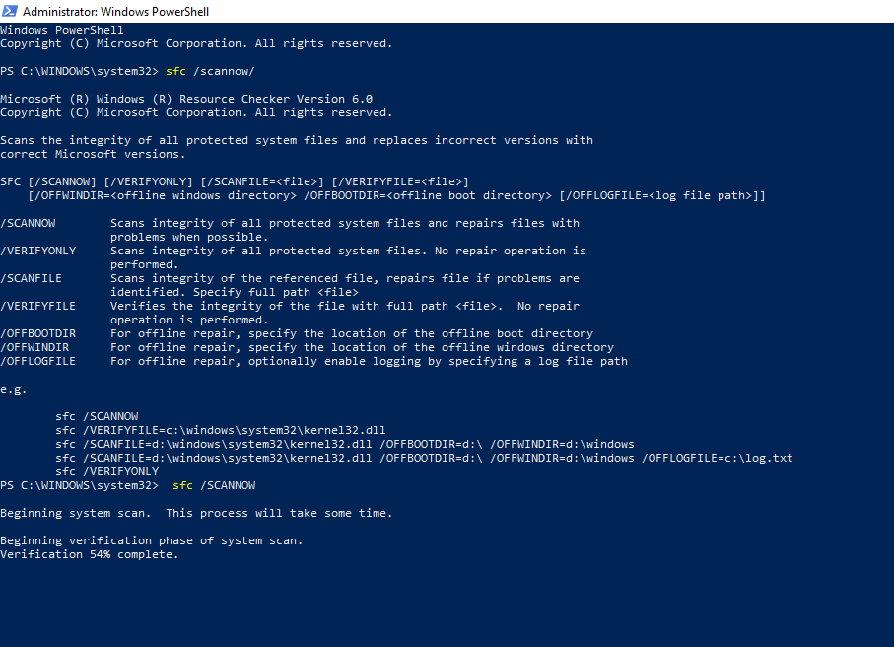

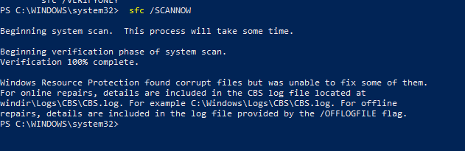

**3. How many malware threats did your scan find?**

**None**

**4. How would you increase the performance of your windows system?**

-Delete system junk

-Uninstall obsolete applications

-Troubleshoot and fix OS issues

-Verify if system is fully up to date

-Scan and remove malware

-Find and fix corrupted OS files

-Fix corrupted file system files of OS